DOCUMENTATION

Presented by RUPINDER SINGH

Introduction -: The assignment is about Russian Roulette game which is all about luck. In this game player will get one revolver with only one bullet. After loads a bullet ,player will spin the chamber of the revolver. They have more than one chance to shoot the bullet but he/she failed to fire the bullet in first two attempt then they will loose the game. The player will also get 10 points if he/she shoot the the bullet on first attempt and 5 points if its on second attempt.

Form1 -: This is the first page of the game where a simple image used as a background. The name of game is written on a top center of the page, there is next button on the bottom. By clicks on next button, the welcome page will appears that is form 2.

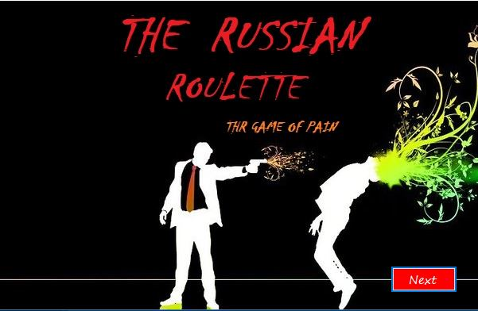

Form2 -: This is a welcome page of the game, here player can also write his/her details before playing game. There are two button on this page first is rules and second is play. If player wants to learn about game before then he/she should click rules button otherwise player can directly play the game by clicks on play button.

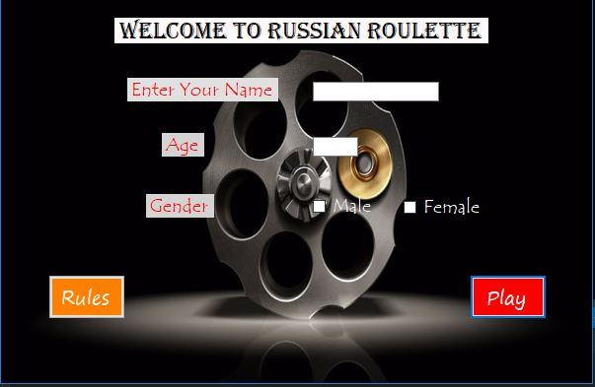

Form3 -: The form3 is a rules page of the game where new player can learn the rules of the game and will know how to play the game. There are two active buttons one is for going backward and second is for going to the final page of the game.

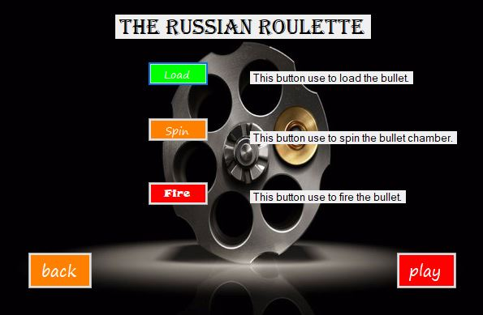

Form4 -: This is a final page of the game where five buttons are available which are load, spin, fire, try again and exit. The name of the player shown on top left corner of the page. The picture box for gif files is located in a center of the page. The score will automatically shown on the screen through pop up message after win or loss.

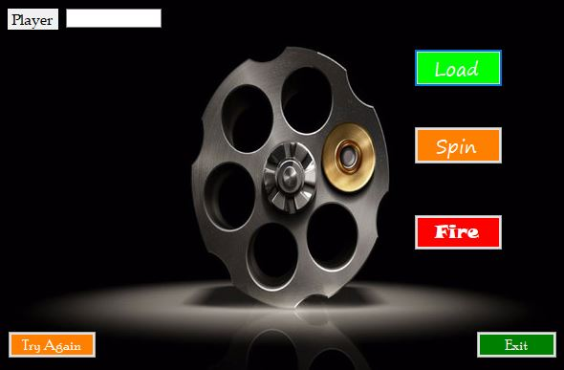

Load button -: The load button helps to load only one bullet in a bullet chamber. The gif is used to make page more impressive.

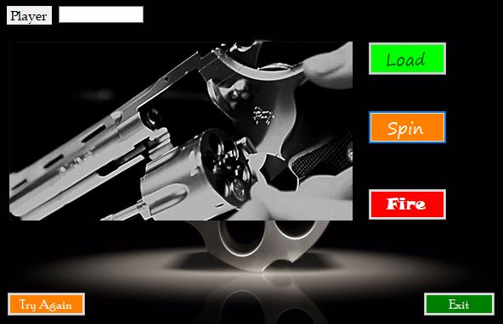

Spin button -: This button helps to spin the bullet chamber randomly. The gif of spinning chamber will appear on the screen after clicks on the spin button

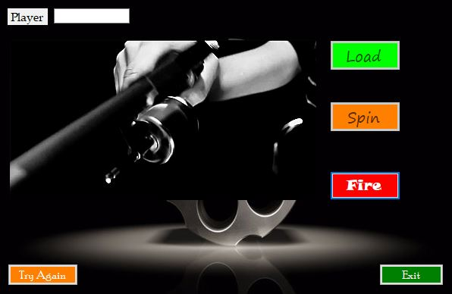

Fire button -: This is the button on which whole game depends, means the main button of the game. By clicks on the fire button bullet will be fired and pop up message will shown on the screen.

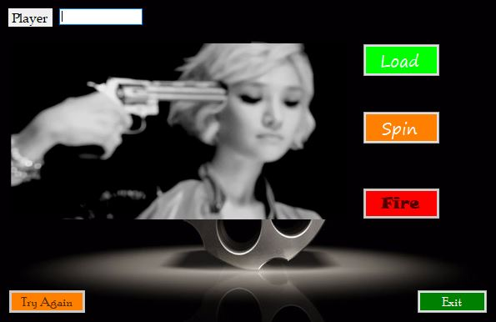

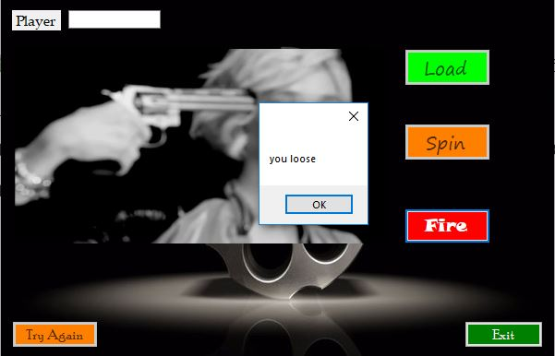

These are pictures that used as a background wallpaper in a game.(source google)

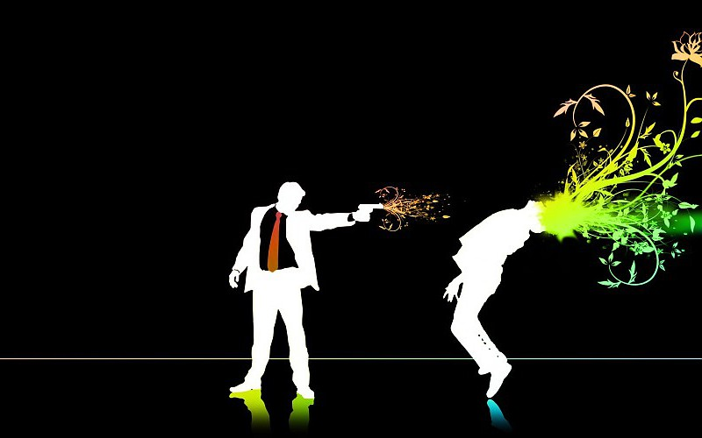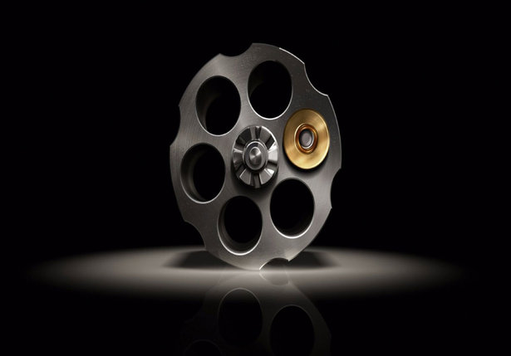

These are the gif files which helps to show the action after clicking these three buttons load, spin ,fire.(source google)

